Lab Exam 1 Winter 2021

CST8116 Introduction to Computer Programming

Student name: Zahi Masarwa

Lab Section:303

Date:02/16/2021

Lab Professor: Mel Sanschagrin

# UML Class Diagram

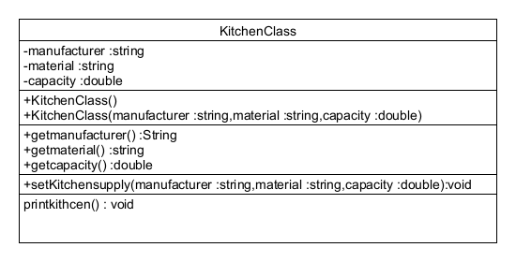

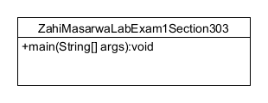

# Screen shot of program execution

